CIS 2109 Lab 6

10/14/2018

Scott O’Hara

**Part 1:**

1. Is this relation in 1NF? If not create the 1NF. If yes, explain why.

Yes, the relation is in 1NF because it has unique rows and no multiple value attributes.

1. Write down the functional dependencies:

Store_name -> Store_Mgr, Revenue, Opening_Date

Emp_Id -> Emp_salary, Emp_super, Emp_dept

Store_Name, Emp_Id -> Hours_per_week, Rating

1. Use the functional dependencies to explain what the candidate key is:

Candidate Key: Store_Name, Emp_Id

1. Transform to 2NF:

STORES (Store_Name, Store_Mgr, Revenue, Opening_Date)

EMPLOYYE (Emp_Id, Emp_salary, Emp_super, Emp_dept)

STORE_EMPLOYEES_HRS_Rating (Store_Name, Emp_Id, Hours_per_week, Rating)

1. Transform to 3NF:

STORES (Store_Name, Store_Mgr, Opening_Date)

EMPLOYYE (Emp_Id, Emp_salary, Emp_dept)

DEPT_SUPER (Emp_dept, Emp_super)

STORE_EMPLOYEES_HRS_Rating (Store_Name, Emp_Id, Hours_per_week, Rating)

**Part 2:**

CREATE TABLE DEPT_SUPER

(Emp_Dept NUMBER(2,0),

Emp_super VARCHAR(10),

CONSTRAINT Dept_PK PRIMARY KEY (Emp_Dept));

CREATE TABLE EMPLOYEE

(Emp_Id VARCHAR(6) NOT NULL,

Emp_salary NUMBER(8,0) NOT NULL,

Emp_Dept NUMBER(4,0),

CONSTRAINT Emp_PK PRIMARY KEY (Emp_Id),

CONSTRAINT Dept_FK FOREIGN KEY (Emp_Dept) REFERENCES DEPT_SUPER(Emp_Dept));

CREATE TABLE STORES

(Store_Name VARCHAR(10) NOT NULL,

Store_Mgr VARCHAR(25),

Opening_Date DATE,

Revenue NUMBER(15),

CONSTRAINT Store_PK PRIMARY KEY (Store_Name));

CREATE TABLE STORE_EMPLOYEES_HRS_Rating

(Store_Name VARCHAR(10) NOT NULL,

Emp_Id VARCHAR(6) NOT NULL,

Hours_per_week NUMBER(4,0),

Rating NUMBER(2,0),

CONSTRAINT Store_Name_FK FOREIGN KEY (Store_Name) REFERENCES STORES(Store_Name),

CONSTRAINT Emp_FK FOREIGN KEY (Emp_Id) REFERENCES EMPLOYEE(Emp_Id));

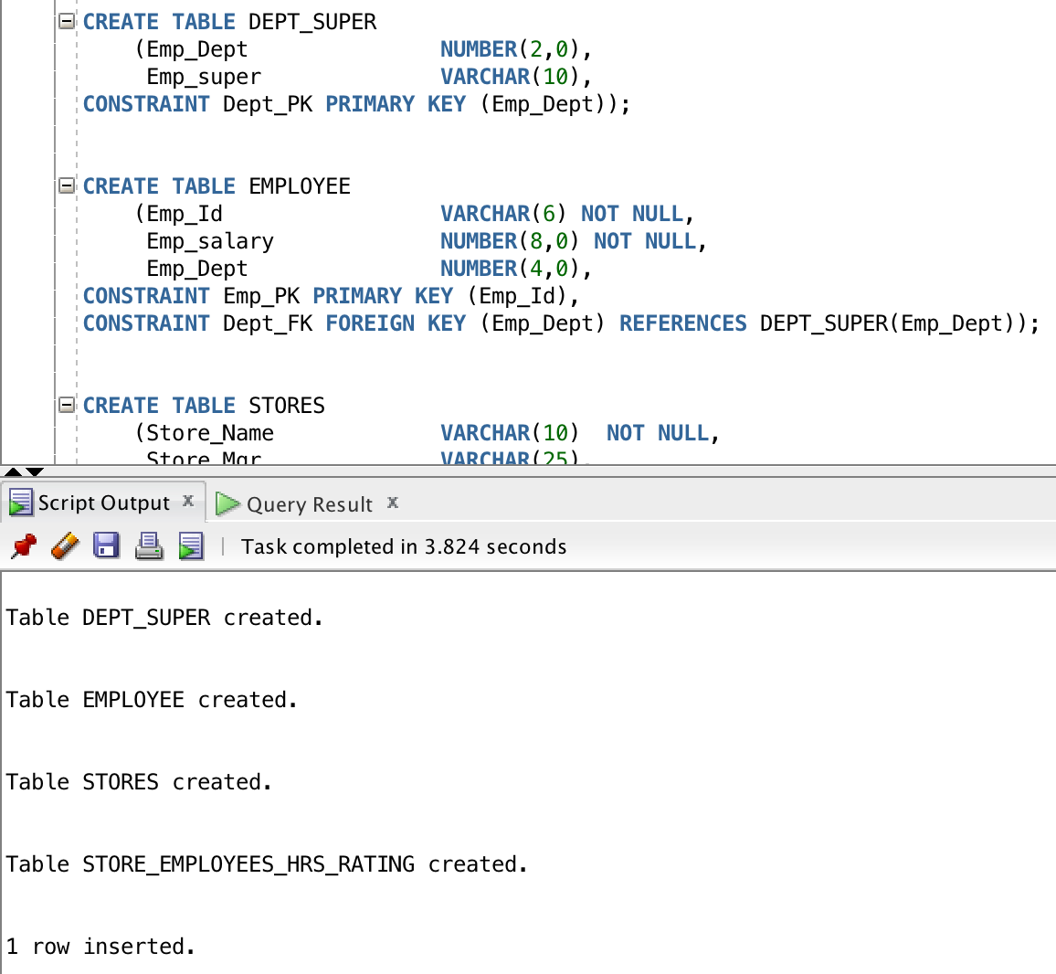

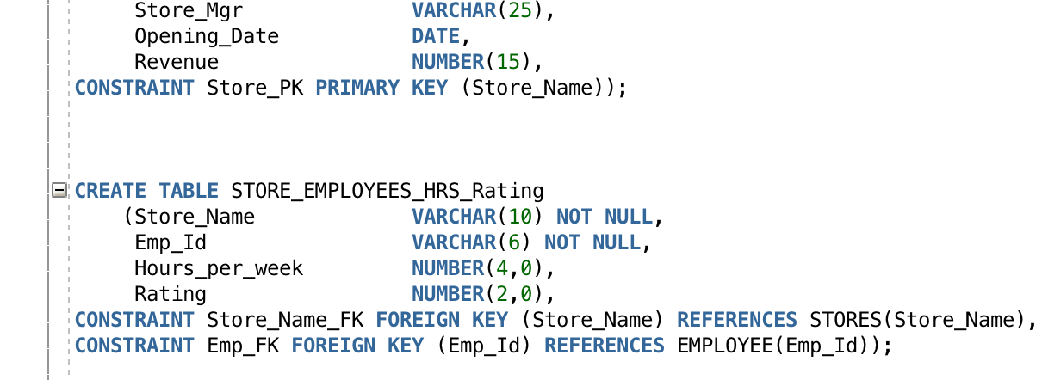

INSERT INTO dept_super (Emp_Dept, Emp_super) VALUES (10, 'Levine');

INSERT INTO dept_super (Emp_Dept, Emp_super) VALUES (12, 'Jones');

INSERT INTO dept_super (Emp_Dept, Emp_super) VALUES (15, 'Jones');

INSERT INTO employee (Emp_Id, Emp_salary, Emp_Dept) VALUES ('E-101', 60000, 10);

INSERT INTO employee (Emp_Id, Emp_salary, Emp_Dept) VALUES ('E-105', 55000, 12);

INSERT INTO employee (Emp_Id, Emp_salary, Emp_Dept) VALUES ('E-110', 43000, 10);

INSERT INTO employee (Emp_Id, Emp_salary, Emp_Dept) VALUES ('E-120', 45000, 15);

INSERT INTO stores (Store_Name, Store_Mgr, Opening_Date, revenue) VALUES ('PA_store', 'Jones', to_date('1/15/2015', 'MM/DD/YYYY'), 100000);

INSERT INTO stores (Store_Name, Store_Mgr, Opening_Date, revenue) VALUES ('NJ_store', 'Smith', to_date('3/1/2014', 'MM/DD/YYYY'), 200000);

INSERT INTO store_employees_hrs_rating (Store_Name, Emp_Id, Hours_per_week, Rating) VALUES ('PA_store', 'E-101', 25, 9);

INSERT INTO store_employees_hrs_rating (Store_Name, Emp_Id, Hours_per_week, Rating) VALUES ('PA_store', 'E-105', 40, 8);

INSERT INTO store_employees_hrs_rating (Store_Name, Emp_Id, Hours_per_week, Rating) VALUES ('PA_store', 'E-110', 10, 8);

INSERT INTO store_employees_hrs_rating (Store_Name, Emp_Id, Hours_per_week, Rating) VALUES ('NJ_store', 'E-101', 15, 7);

INSERT INTO store_employees_hrs_rating (Store_Name, Emp_Id, Hours_per_week, Rating) VALUES ('NJ_store', 'E-110', 30, 9);

INSERT INTO store_employees_hrs_rating (Store_Name, Emp_Id, Hours_per_week, Rating) VALUES ('NJ_store', 'E-120', 40, 9);

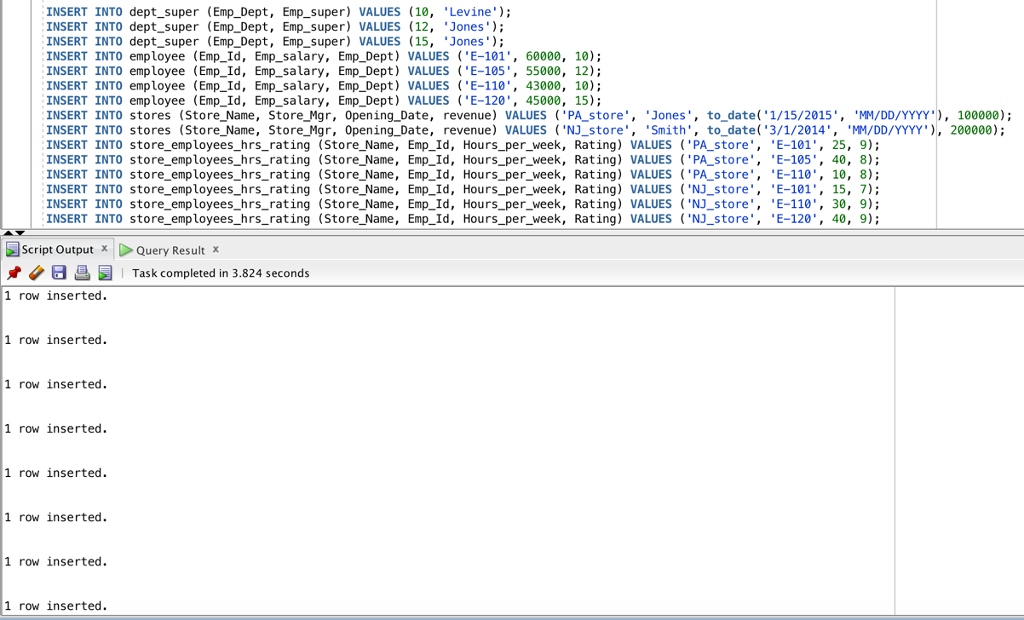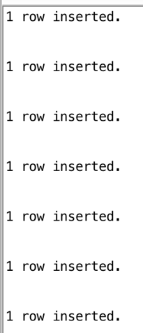

**Part 3:**

select s.store_name, s.store_mgr, e.emp_id, se.hours_per_week, s.revenue, to_char(s.opening_date, 'MM/DD/YYYY') as Opening_Date, e.emp_salary, ds.emp_super, ds.emp_dept, se.rating

from employee e inner join dept_super ds on ds.emp_dept = e.emp_dept

inner join store_employees_hrs_rating se on e.emp_id = se.emp_id

inner join stores s on se.store_name = s.store_name;

